**How to Declare Investment**

# Investment proof declaration





## How to Login ?

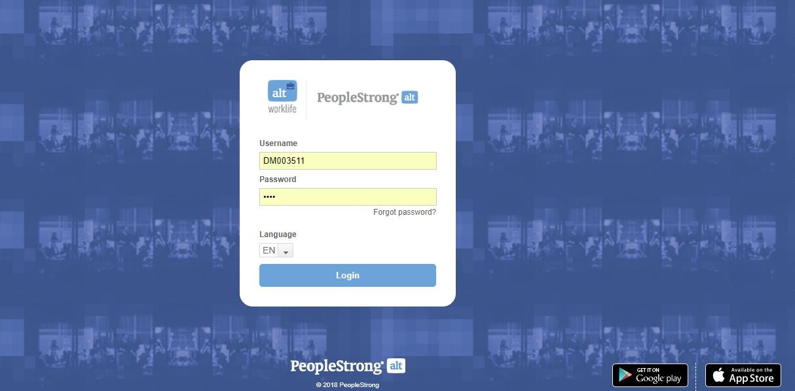

Enter your User Name Enter your Password

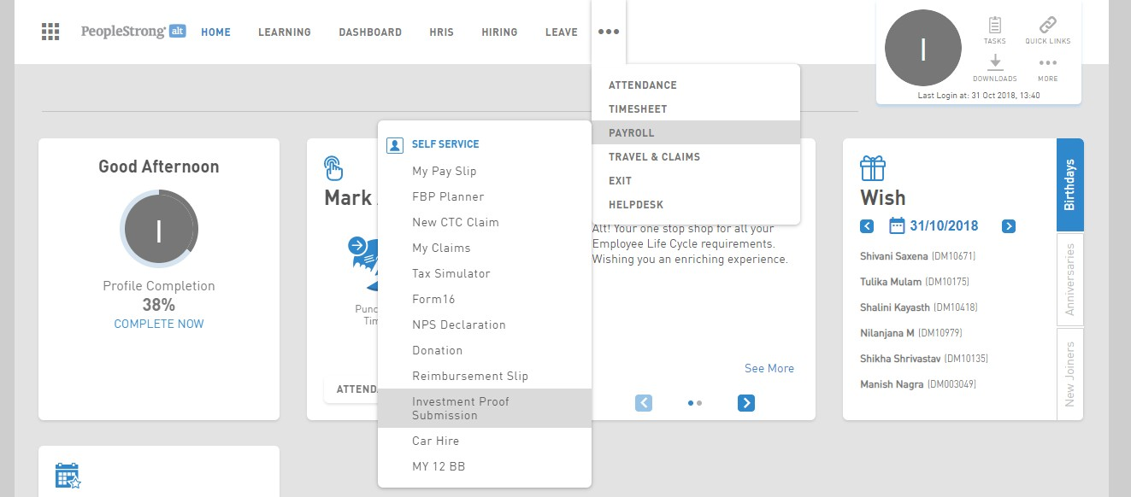

**1**

**2**

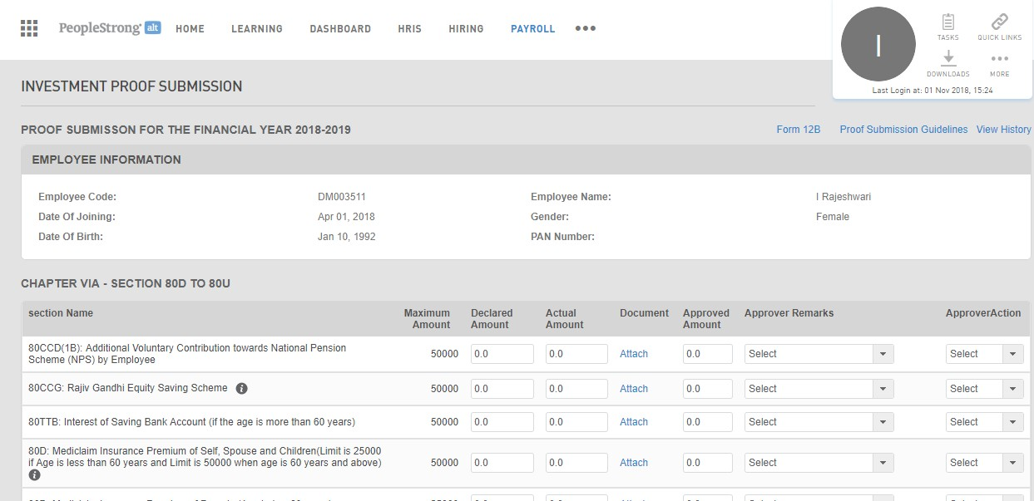

### Click here to download guidelines

**How to declare National Pension Scheme (NPS)?**



**Attach the file with the certificate of doument**

Enter the amount paid by you under National pension scheme **(Max limit 50,000)**

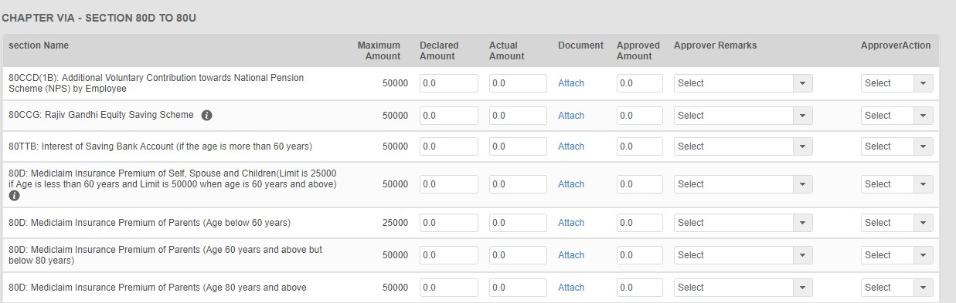

**How to declare Mediclaim ?**

Enter Mediclaim Premium for **(Parents age more than 80) maximum limit 50,000**

Enter Mediclaim Premium for **Parents age more than 60 & less than 80 (maximum limit 50,000)**

Enter Mediclaim Premium for **Self, Child or Spouse (**maximum limit **50,000 if age is more than 60) ; (25,000 if age less than 60)**

Enter Mediclaim Premium for **Parents age less than 60 (maximum limit 25,000)**

**How to declare LIC ?**

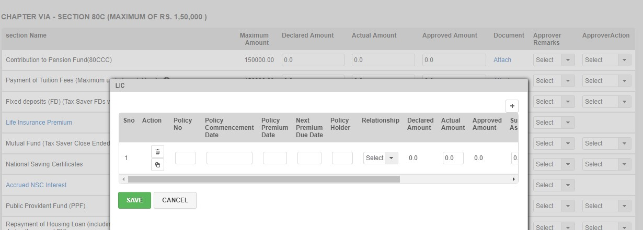

Enter Date of commencement

Enter policy Premium date mentioned on the document

Enter Name of policy holder(self, child or spouse)

Click on Life Insurance Premium

and you will get a POP UP SCREEN

Enter Policy Number mentioned on document

Enter premium due date

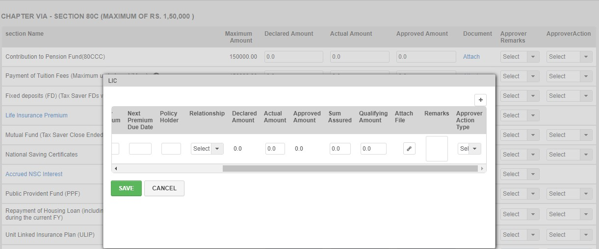

**20% of amount assured, example: sum assured is 5 lacs qualifying amount will be 1 lac**

Enter actual amount paid

Click **+** if you have **multiple policies**, fill all the details

Enter Relationship with policy holder (self, child or spouse)

Enter the sum assured

Attach the Policy Document

**(Size max 5mb)**

Once entered all the

details click save

Start date (actual date of month)

the rent paid

Enter the city from drop down menu

Rent Declared to be **Monthly**

Attach your rent receipt

**\*It should have date and revenue**

**stamp.**

End date(actual date of month)

## How to declare House Rent ?

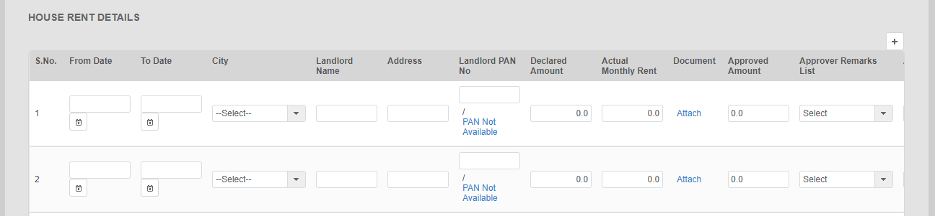

Click **+** if you have **changed your house and paid rent to different owners post filling all 12 entries available in the form.**

Enter PAN number of Landlord if rent paid per month is **more than Rs 8,333**

**How to declare interest on Housing loan(let out)?**

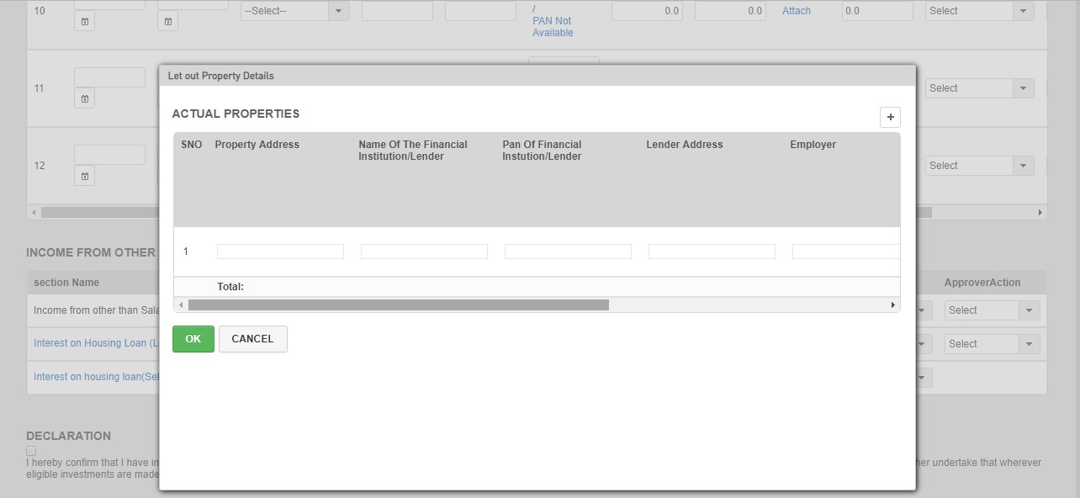

Name of your company

Enter you property address

PAN of the company

Click on Interest on housing loan(let out) and you will get a POP UP SCREEN

Name of the loan company

Address of the loan company

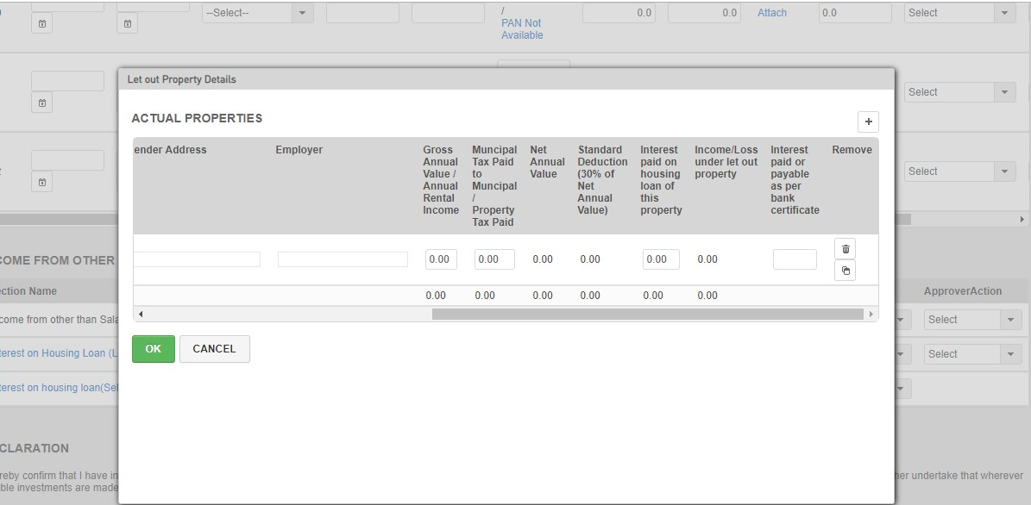

Click **+** if you have multiple loan on different properties which are let out

Enter Annual rent received by you

Enter House tax paid

Enter interest paid by for house loan amount mentioned in document/receipt

Click ok once you have filled all fields

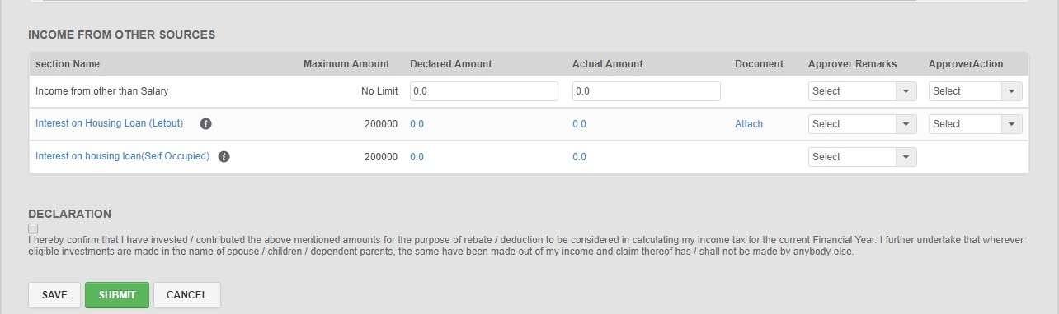

Please select this option if you have any doubts or clarification is required and your form is incomplete

Please check this box once you have filled the investment proof

Please select this option if you have filled entire investment declaration form and you are confident that given information is correct as this will affect your **SALARY & TAX DEDUCTION**

# #SimplifyWorklife

Corporate Office

A 10 Infocity, Sector 34, Gurgaon, Haryana - 122001 E: [contact@peoplestrong.com](mailto:contact@peoplestrong.com)

M: +91 9560998686 | T: +911244782400 | F: +911244273762





© PeopleStrong.Disclosure not permitted